 | 12.1.43 Editors - Geometry Nodes Editor - Header - Add Menu - Texture
Table of content
Detailed table of content 1
Add menu - Texture 5
Brick Texture 5
Checker Texture 6
Gabor Texture 7
Gradient Texture 8
Image Texture 9
Magic Texture 11
Noise Texture 11
Voronoi Texture 14
Wave Texture 16
White Noise Texture 17

Detailed table of content
Detailed table of content
Detailed table of content 1
Add menu - Texture 5
Brick Texture 5
Inputs 5
Color 1, Color 2 and Mortar 5
Scale 5
Mortar Size 5
Mortar Smooth 5
Bias 5
Brick Width 5
Row Height 5
Properties 5
Offset 5
Frequency 6
Squash 6
Frequency 6
Outputs 6
Color 6
Factor 6
Checker Texture 6
Inputs 6
Vector 6
Color 1 6
Color 2 6
Scale 6
Output 6
Color 6
Factor 7
Gabor Texture 7
Properties 7
2D Mode 7
Vector 7
Scale 7
Frequency 7
Anisotrophy 7
Orientation 7
3D Mode 7
Scale 7
Frequency 7
Anisotrophy 8
Orientation 8
Output 8
Value 8
Phase 8
Intensity 8
Gradient Texture 8
Inputs 8
Vector 8
Properties 8
Gradient Type 8
Output 8
Factor 8
Color 8
Image Texture 9
Inputs 9
Image 9
Image Browser 9
New/Open 9
Image Edit Box 9
Fake User 9
New Image 9
Open Image 9
Remove 9
Vector 9
Frame 10
Properties 10
Interpolation 10
Linear 10
Closest 10
Cubic 10
Extension 10
Repeat 10
Extend 10
Clip 10
Mirror 10
Outputs 10
Color 10
Alpha 10
Magic Texture 11
Inputs 11
Vector 11
Scale 11
Distortion 11
Properties 11
Depth 11
Outputs 11
Color 11
Factor 11
Noise Texture 11
Inputs 12
Vector 12
Normalize 12
W 12
Scale 12
Detail 12
Roughness 12
Lacunarity 12
Offset 12
Gain 12
Distortion 13
Properties 13
Dimensions 13
1D 13
2D 13
3D 13
4D 13
Type 13
Multifractal 13
Ridged Multifractal 13
Hybrid Multifractal 13
fBM (fractal Brownian Motion) 13
Hetero Terrain (Heterogeneous Terrain) 13
Outputs 14
Factor 14
Color 14
Voronoi Texture 14
Inputs 14
Vector 14
W 14
Scale 14
Detail 14
Roughness 14
Lacunacy 14
Smoothness 14
Randomness 14
Properties 15
Dimensions 15
Feature Output 15
F1 15
F2 15
Smooth F1 15
Distance to Edge 15
N-Sphere Radius 15
Distance Metric 15
Normalize 15
Output 15
Factor 15
Color 15
Wave Texture 16
Inputs 16
Vector 16
Scale 16
Distortion 16
Detail 16
Detail Scale 16
Detail Roughness 16
Phase Offset 16
Properties 16
Wave Type 16
Bands direction 16
Wave Profile 16
Saw 17
Sine 17
Triangle 17
Outputs 17
Color 17
Factor 17
White Noise Texture 17
Inputs 17
Vector 17
Properties 17
Dimensions 17
Output 17
Vector 17
Color 17

Add menu - Texture
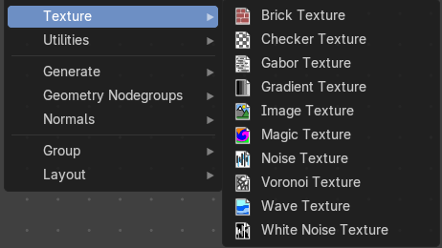
Texture nodes.

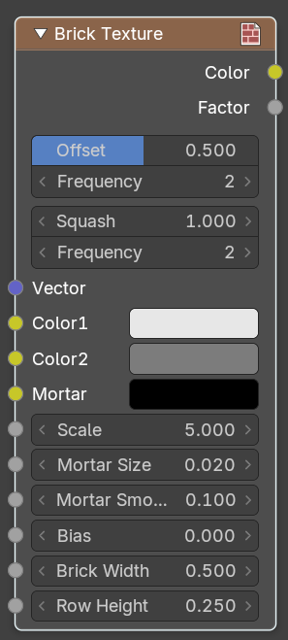
Brick Texture
The Brick Texture node is used to add a procedural brick texture.

Inputs

Color 1, Color 2 and Mortar
Color of the bricks and mortar.

Scale
Overall texture scale.

Mortar Size
The size of the filling between the bricks known as “mortar”; 0 means no mortar.

Mortar Smooth
Blurs/softens the edge between the mortar and the bricks. This can be useful with a texture and displacement textures.

Bias
The color variation between Color 1/2. Values of -1 and 1 only use one of the two colors; values in between mix the colors.

Brick Width
The width of the bricks.

Row Height
The height of the brick rows.

Properties

Offset
Determines the brick offset of the various rows.

Frequency
Determines the offset frequency. A value of 2 gives an even/uneven pattern of rows.

Squash
Amount of brick squashing.

Frequency
Brick squashing frequency.

Outputs

Color
Texture color output.

Factor
Mortar mask (1 = mortar).

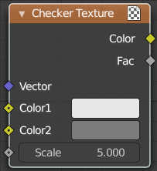
Checker Texture
Adds a checker texture.

Inputs

Vector
Vector input.

Color 1
The first checker color.

Color 2
The second checker color.

Scale
The scale of the checker texture.

Output

Color
The checker texture output.

Factor
Factor output.

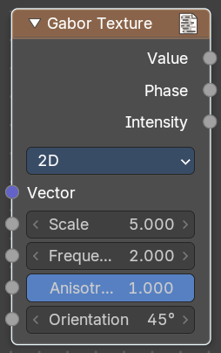
Gabor Texture
Adds a Gabor texture.

Properties

2D Mode
Uses the X Y vector. Z value is ignored.

Vector
Vector input.

Scale
The scale of the gabor noise.

Frequency
The rate at which the gabor noise changes across space. The scale is global, the frequency relative to the current noise direction.

Anisotrophy
The directionality of gabor noise. A value of 1 is completely directional, while a value of 0 is omnidirectional.

Orientation
The direction of the anisotropic gabor noise. It is an angle, since it is 2d.

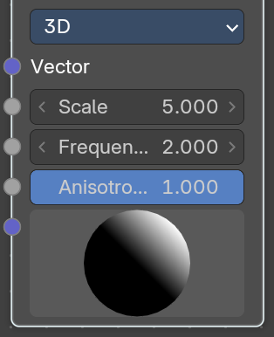
3D Mode

Scale
The scale of the gabor noise.

Frequency
The rate at which the gabor noise changes across space. The scale is global, the frequency relative to the current noise direction.

Anisotrophy
The directionality of gabor noise. A value of 1 is completely directional, while a value of 0 is omnidirectional.

Orientation
The direction of the anisotropic gabor noise. It is oriented in the 3d space. And can be adjusted with the 3d widget.

Output

Value
The sum of gabor phase and intensity.

Phase
The gabor phase.

Intensity
The gabor intensity.

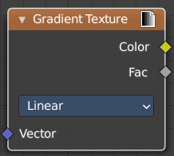
Gradient Texture
Add a gradient texture.

Inputs

Vector
Vector input.

Properties

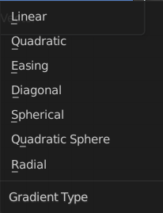
Gradient Type
What gradient type to use.

Output

Factor
Factor output.

Color
Color output.

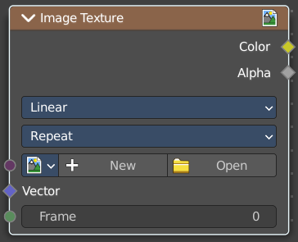
Image Texture
The Image Texture is used to add an image file as a texture.

Inputs

Image
The Image input. Open an image, choose an existing image, or generate a new image.
When you click at Open then a file browser opens up. When you click at New then a popup dialog opens. up where you can create a new image.

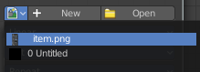
Image Browser
The image browser at the left allows you to pick an already existing texture.

New/Open
Create a new image, or open an image.

Image Edit Box
The name of the image.

Fake User
Keep the texture in the blend file even if it is not used.

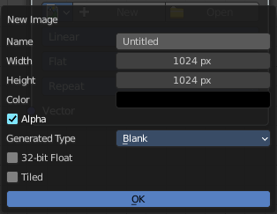
New Image
Create a new image.
The settings of this image can be further adjusted in the sidebar of the UV Editor.

Open Image
Open an image.

Remove
Remove the image. Note that it is still in the blend file as long as it has users, and as long as you haven't purged it. By saving and reloading the blend file for example.

Vector
Texture coordinate for texture look-up. If this socket is left unconnected, UV coordinates from the active UV render layer are used.

Frame
The frame of an image sequence, if available.

Properties

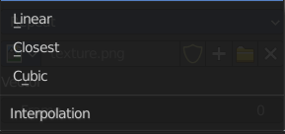
Interpolation
Method to scale images up or down for rendering.

Linear
Regular quality interpolation.

Closest
No interpolation, use only closest pixel for rendering pixel art.

Cubic
Smoother, better quality interpolation. For bump maps this should be used to get best results.

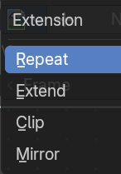
Extension
Extension defines how the image is extrapolated past the original bounds:

Repeat
Will repeat the image horizontally and vertically giving tiled-looking result.

Extend
Will extend the image by repeating pixels on its edges.

Clip
Clip to the original image size and set all the exterior pixels values to transparent black.

Mirror
Flip the image horizontally and vertically repeatedly.

Outputs

Color
RGB color from image. If the image has alpha, the color is premultiplied with alpha if the Alpha output is used, and unpremultiplied or straight if the Alpha output is not used.

Alpha
Alpha channel from image.

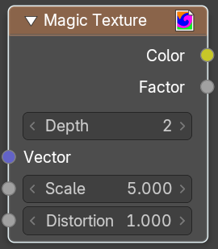
Magic Texture
The Magic Texture node is used to add a procedural psychedelic color texture.

Inputs

Vector
Texture coordinate to sample texture at; defaults to Generated texture coordinates if the socket is left unconnected.

Scale
Scale of the texture.

Distortion
Amount of distortion.

Properties

Depth
Number of iterations.

Outputs

Color
Texture color output.

Factor
Texture intensity output.

Noise Texture
The Noise Texture node evaluates a fractal Perlin noise at the input texture coordinates. This nodes allows great control over how noise octaves are combined.
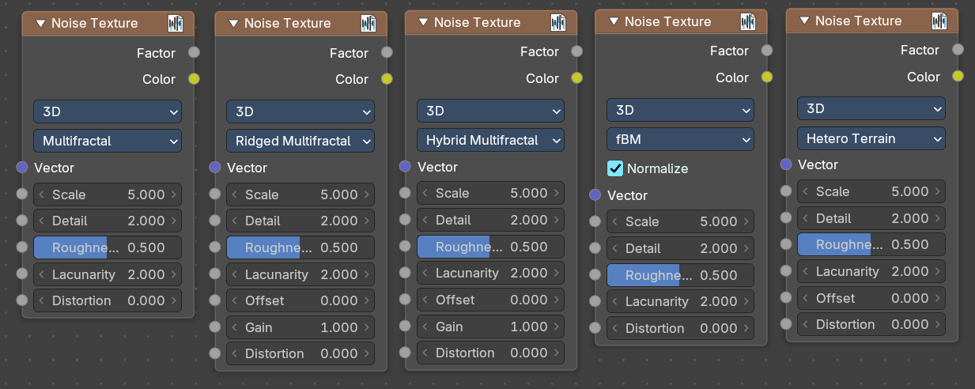

Inputs
The inputs are dynamic, they become available if needed depending on the node properties.

Vector
Texture coordinate to evaluate the noise at; defaults to Generated texture coordinates if the socket is left unconnected.

Normalize
Normalize the output to the 0 - 1 range.

W
Texture coordinate to evaluate the noise at. Appears with 4 dimensions.

Scale
Scale of the base noise octave.

Detail
Number of noise octaves. The fractional part of the input is multiplied by the magnitude of the highest octave. Higher number of octaves corresponds to a higher render time.

Roughness
Adds a roughness noise.

Lacunarity
The scale of a perlin noise octave relative to the perlin noise octave from the previous octave.

Offset
An added offset to each octave, determines the level where the highest octave will appear.

Gain
An extra multiplier to tune the magnitude of octaves.

Distortion
Amount of distortion.

Properties

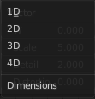
Dimensions
The dimensions of the space to evaluate the noise in.

1D
Evaluate the noise in 1D space at the input W.

2D
Evaluate the noise in 2D space at the input Vector. The Z component is ignored.

3D
Evaluate the noise in 3D space at the input Vector.

4D
Evaluate the noise in 4D space at the input Vector and the input W as the fourth dimension.

Type
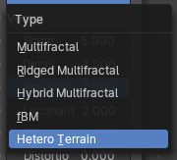
Type of the perlin noise texture.

Multifractal
The result is more uneven (varies with location), more similar to a real terrain. Uses a multiplicative cascade.

Ridged Multifractal
Creates sharp peaks. Calculates the absolute value of the noise, creating “canyons”, and then flips the surface upside down.

Hybrid Multifractal
Creates peaks and valleys with different roughness values, like real mountains rise out of flat plains. Combines the additive cascade with a multiplicative cascade.

fBM (fractal Brownian Motion)
Produces an unnatural homogeneous and isotropic result. Uses an additive cascade, the values are simply added together.

Hetero Terrain (Heterogeneous Terrain)
Similar to Hybrid Multifractal creates a heterogeneous terrain, but with the likeness of river channels.

Outputs

Factor
Value of fractal noise.

Color
Color with different fractal noise in each component.

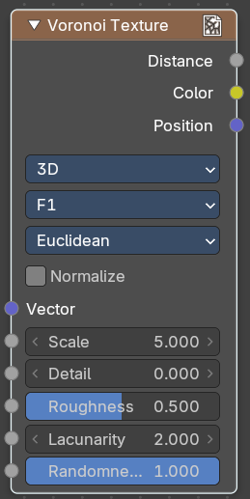
Voronoi Texture
Add a voronoi texture.

Inputs

Vector
Vector input.

W
The value w scale in 4 dimensions.

Scale
The scale of the voronoi texture.

Detail
The number ovf voronoi layers.

Roughness
The influence of the voronoi layer relative to the previous layer.

Lacunacy
The scale of the voronoi layer relative to the previous layer.

Smoothness
Smoothness of Smooth F1

Randomness
The detail of the voronoi texture.

Properties

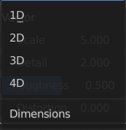
Dimensions
How many dimensions to use for the voronoi texture.

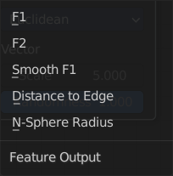
Feature Output
Feature output mode.

F1
Computes the distance to the closest point as well as its position and color.

F2
Computes the distance to the second closest point as well as its position and color.

Smooth F1
Smoothed version of F1.Weighted sum of neighbor voronoi cells.

Distance to Edge
Computes the distance to the edge of the voronoi cell.

N-Sphere Radius
Computes the radius of the n-sphere inscribed in the voronoi cell.

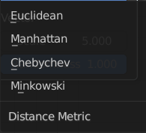
Distance Metric
Distance calculation mode. The modes are different mathematical methods.

Normalize
Normalize the output distance to the 0.0 - 1.0 range.

Output

Factor
Factor output.

Color
Color output.

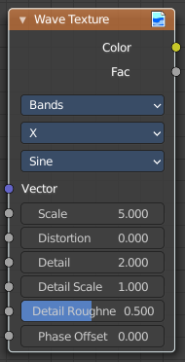
Wave Texture
The Wave Texture node adds procedural bands or rings with noise distortion.

Inputs

Vector
Texture coordinate to sample texture at; defaults to Generated texture coordinates if the socket is left unconnected.

Scale
Overall texture scale.

Distortion
Amount of distortion of the wave (similar to the Marble texture in Blender Internal).

Detail
Amount of distortion noise detail.

Detail Scale
Scale of distortion noise.

Detail Roughness
Adds a roughness noise.

Phase Offset
Set an offset for the phase.

Properties

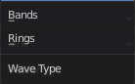
Wave Type
Bands or Rings shaped waves.

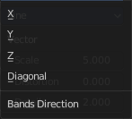
Bands direction
In which direction the bands should point.

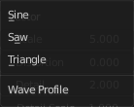
Wave Profile
Controls the shape and look of the wave type.

Saw
Uses a saw tooth profile.

Sine
Uses the standard sine profile.

Triangle
Uses a triangle shape.

Outputs

Color
Texture color output.

Factor
Texture intensity output.

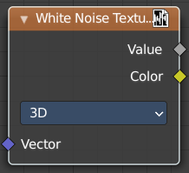
White Noise Texture
Add a white noise texture.

Inputs

Vector
Vector input.

Properties

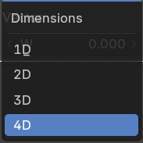
Dimensions
What gradient type to use.

Output

Vector
Factor output.

Color
Color output.

